5 STACK BASED BUFFER OVERFLOW ATTACKS

AIM

To understand the sudo buffer overflow vulnerability (CVE-2019-18634) and learn how it can be exploited for privilege escalation in the TryHackMe room “Sudo Buffer Overflow.”

PROCEDURE

- Open the TryHackMe room “Sudo Buffer Overflow” and study the basics of buffer overflow in sudo.
- Learn how the vulnerability CVE-2019-18634 affects older sudo versions with pwfeedback enabled.
- Understand how the provided exploit is used to gain root access on the target machine.
- Complete the tasks and retrieve the root flag from the system.

QUESTIONS

TASK 2 – Buffer Overflow

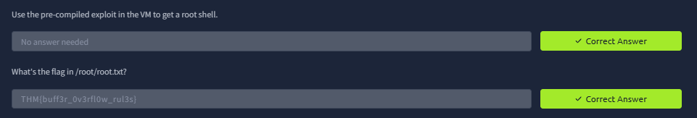

RESULT

Successfully learned how a sudo buffer overflow vulnerability can lead to privilege escalation and gained practical knowledge of exploiting CVE-2019-18634 in Linux systems.

